When I went to save to research. Again don’t know what any of this means. It’s too much information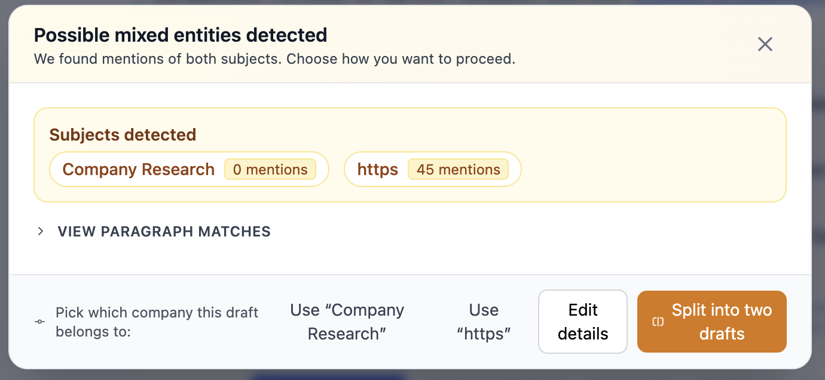

If I click on say on continue this company then click start new company something should move. The highlight is stuck on start new company so you don’t know what is selected. It’s a confusing UX. And nothing happens if I click start new company, email draft, or continue this company. If I click summarize it acts as I would expect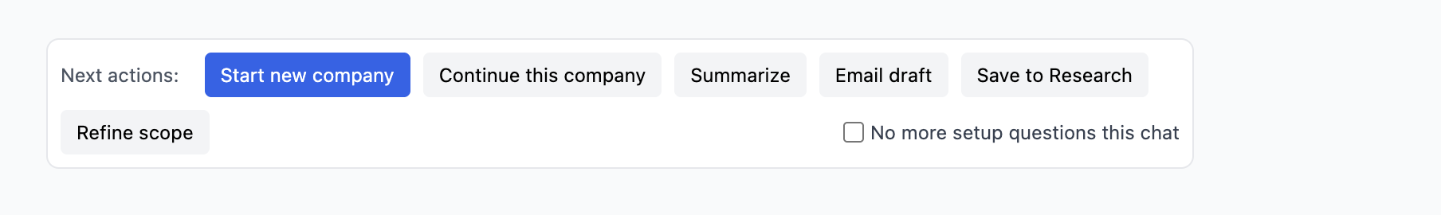When I click on refine scope all 6 of those should be checked (or whatever was set upon setup). It needs to reflect the current state when you click on it and ideally then you can uncheck or check as needed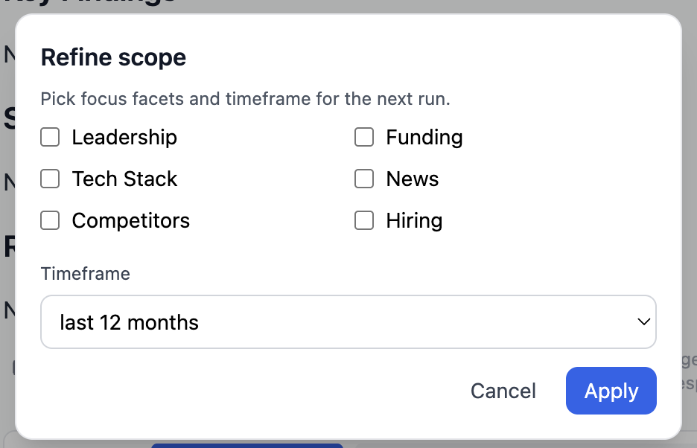

So this is really cool and has a lot of potential. Suggesting things like this and it actually working. Can we make the next steps either clickable or executable somehow. Like if it suggests to do 4 things you can select which ones you want it to help you with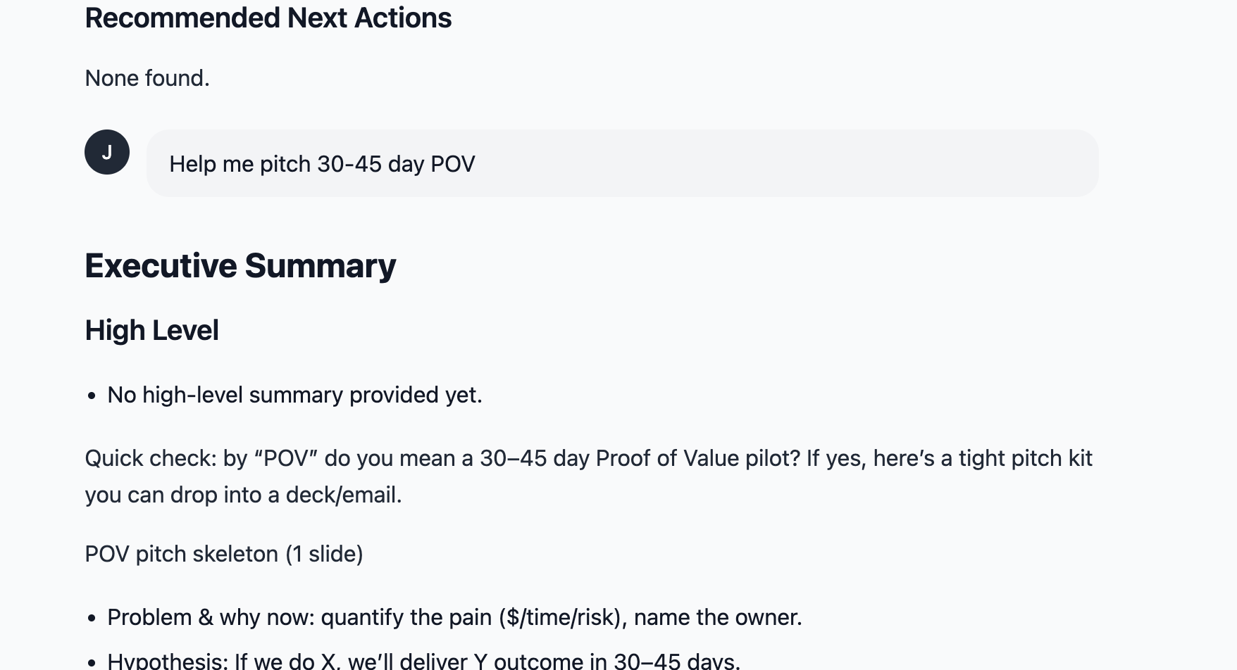This message doesn’t make sense.I just searched for [clair.com](http://clair.com) after searching for keepit and it still shows in the expectations box the original company researched.

Again. It’s not taking context from the research before. I searched clari. Then after it gave me the results I asked a follow up question about their CEO . It shouldn’t have to ask me who I am referring to